Connecting Gigaset N870 to CUCM via Anynode

- Cisco CUCM
  - SIP trunk configuration
    - SIP profile
create a SIP profile for the SIP-Trunk to Anynode with the following parameters:
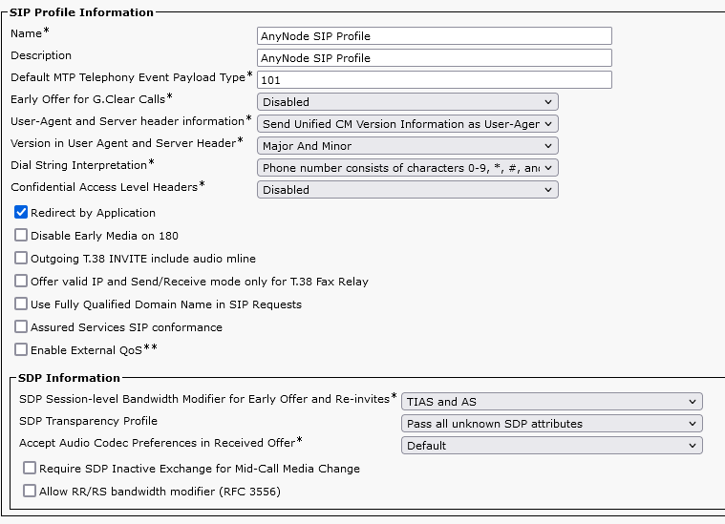
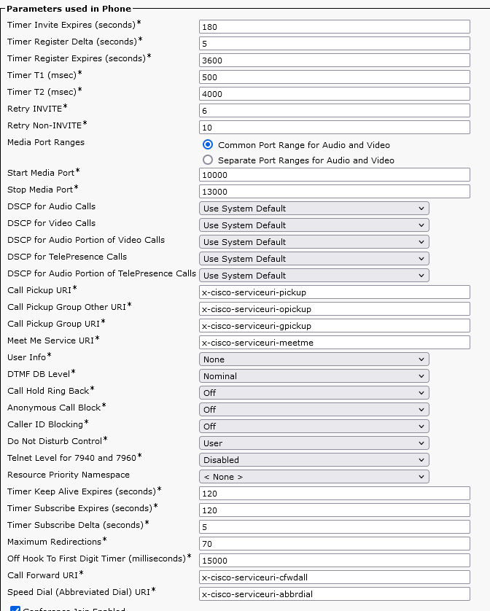
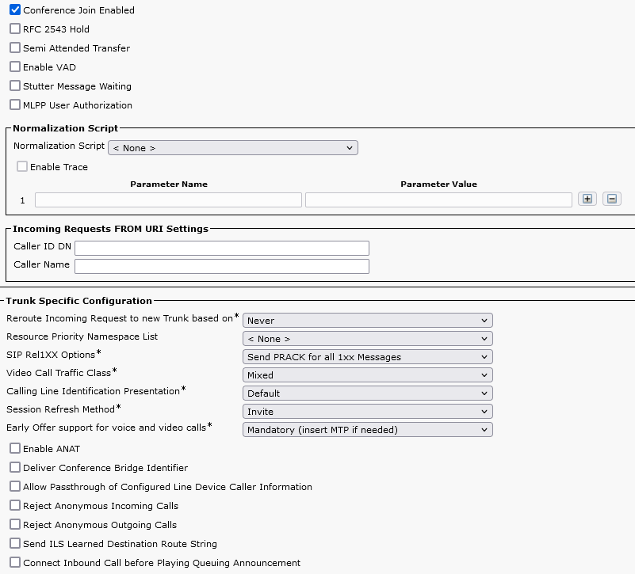
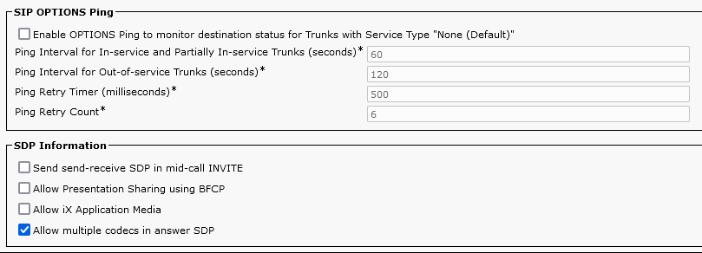
    - SIP Trunk Security profile
Create a SIP trunk security profile with the following parameters:
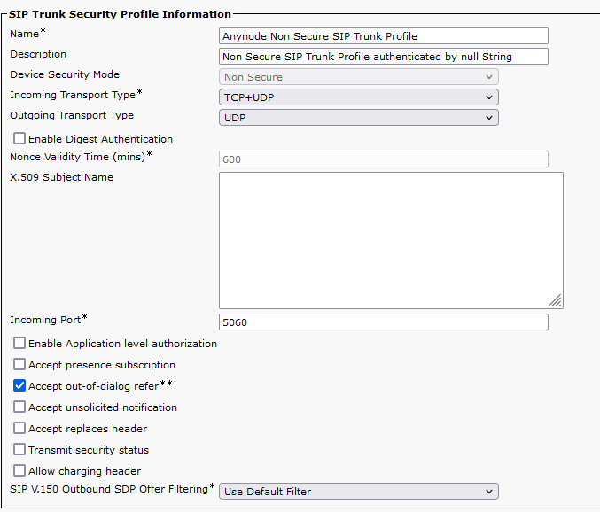
    - SIP trunk
create a SIP trunk with the parameters described below
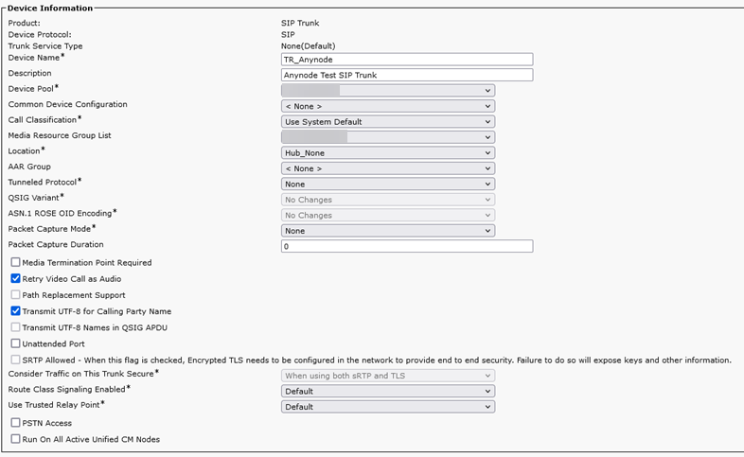
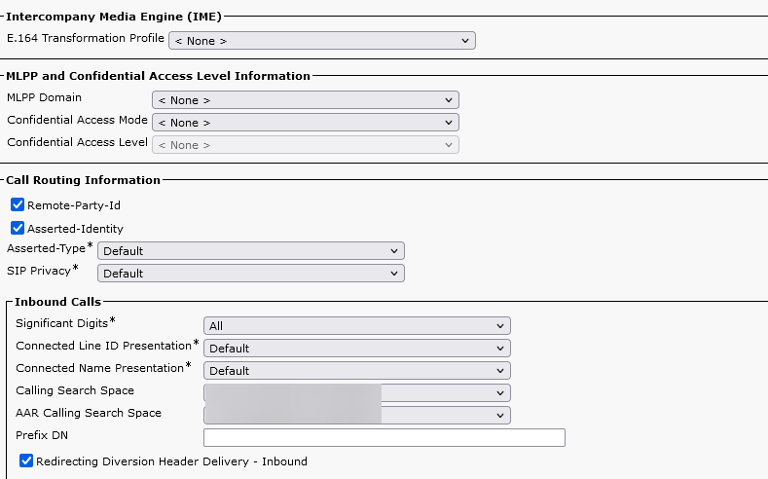
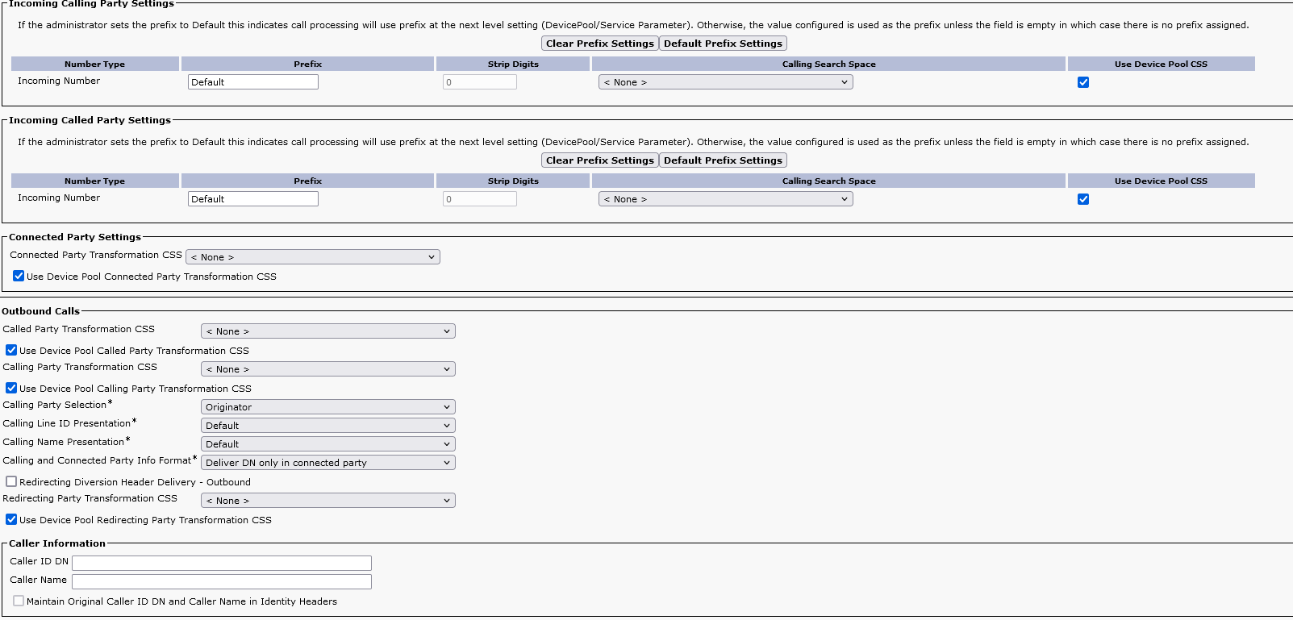
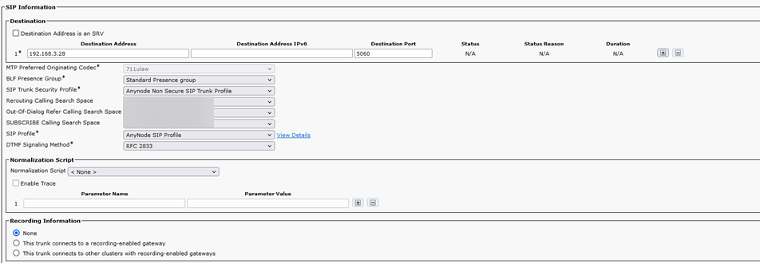
    - Route pattern
      - Create a route pattern for the extension numbers of the DECT system and route it tot he SIP trunk we have created before:
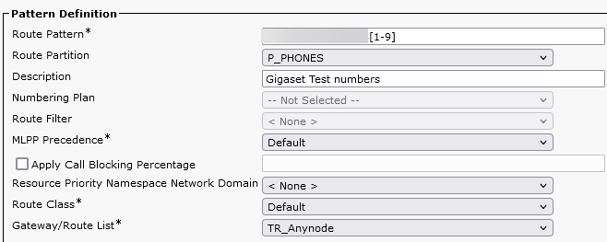
      - SIP route pattern:
A SIP route pattern has to be created. It is needed for the REFER requests in case of a call transfer. The SIP route pattern needs to have the IP address of the ANYNODE SIP interface where the DECT phones are registering to (here 192.168.3.29). Is needs to be routed to the SIP trunk to Anynode we have crated before:
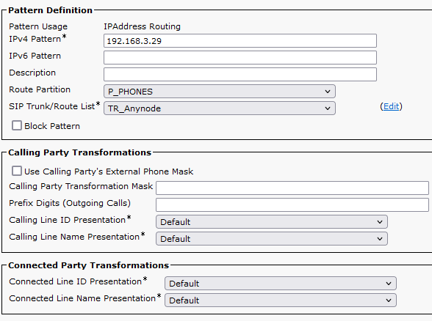
- Anynode SBC
  - General configuration
It is recommended to have 2 seperate interfaces or IP addresses on the AnyNode server. One interface is for the SIP trunk for the CUCM, the second interface is for the registration of the SIP phones. In our example we use the 192.168.3.28 for the CUCM sip trunk and we use the 192.168.3.29 as registrar for the SIP phones.
  - CUCM SIP trunk
Create a SIP trunk to the CUCM as it is described in the AnyNode documentation. It is important that the correct IP address is selected in the network controller in the SIP node:
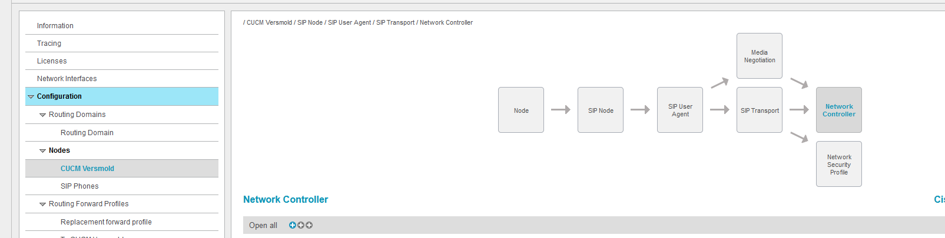
select “Network controller” and “advanced configuration” in the IP address tab:
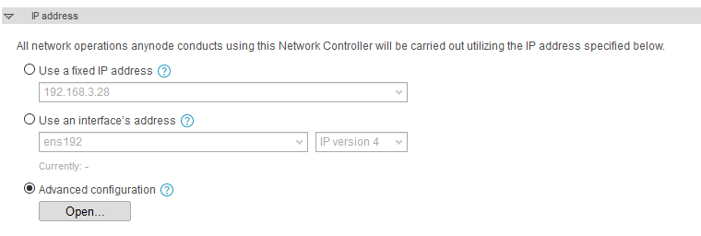
then click on “Open”:
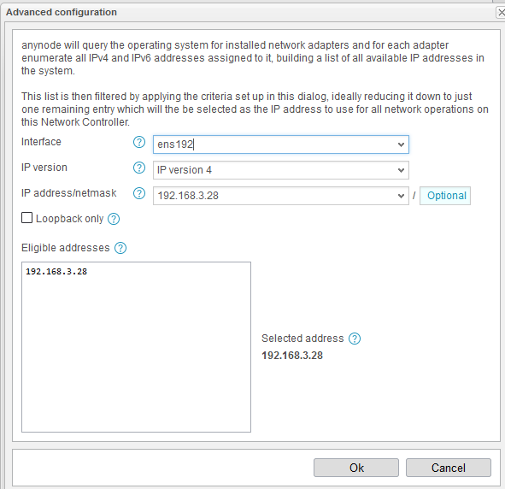
select the IP address you want to use for the CUCM SIP trunk. Here we use 192.168.3.28 .
  - SIP registrar for the DECT phones.
Create a SIP registrar with SIP users as described in the AnyNode system documentation. Here we use a Static User directory for the authentication. Each user has the E.164 number configured as username.
Important for the self provisioning: The SUB ID needs to be the IPUI of the DECT handset. This is important for the auto provisioning service to work properly.
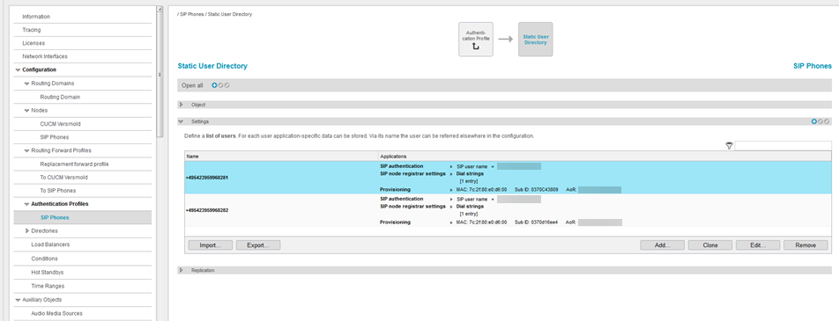
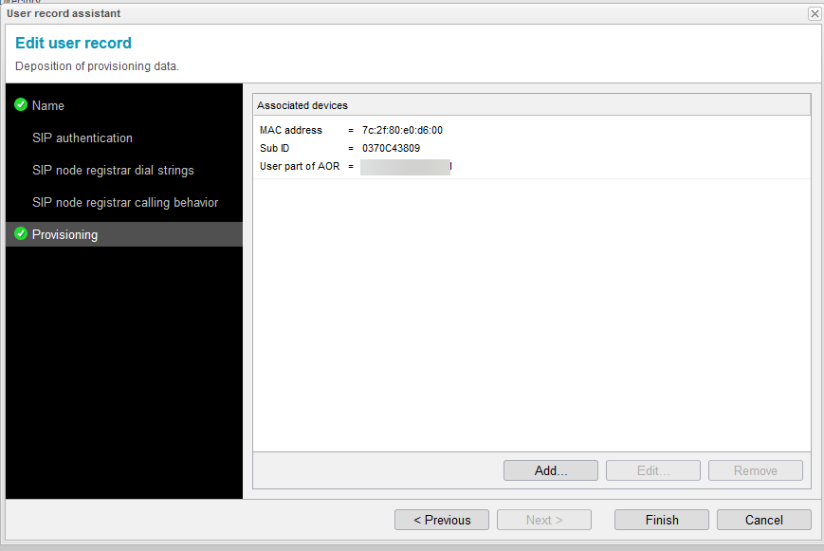
Default settings for the provisioning server are used with the „Gigaset N670 & N870“ template and https.
The default https port is 14001 here. It can be changed in the „http server“ configuration in the provisioning server menu:
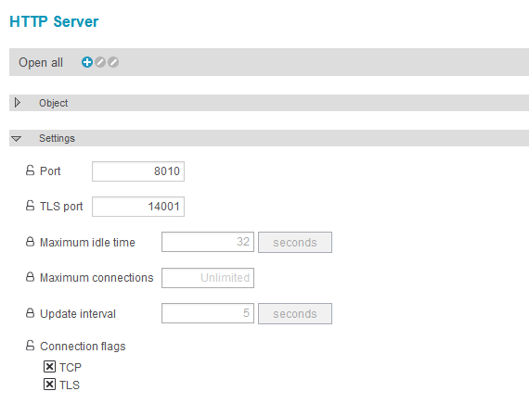
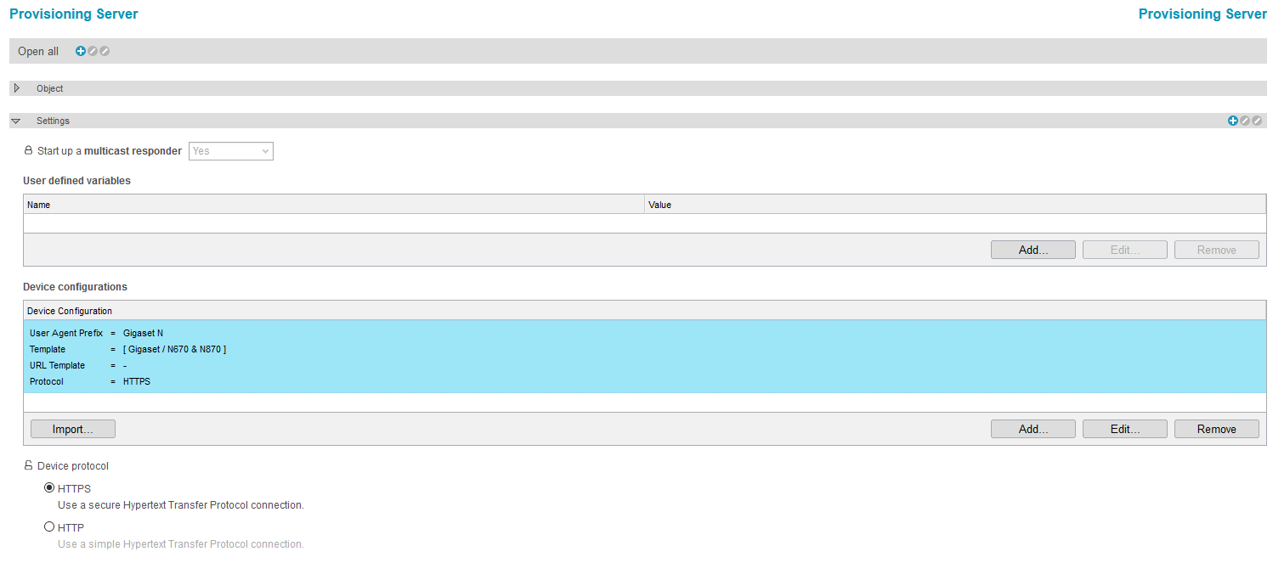
For a better security It is recommended to use https. With http the usernames and password of the extension numbers would be transmitted in clear text.
  - Routing
The routing domain has to be configured as in the following example.
The first route with the highest priority points to the SIP phones.
The destination dial strings come from the SIP phones directory from the SIP registrar we created before.
The second route is pointing to the CUCM and matches with a wild card pattern (All Numbers beginning with 0-9), source nodes are the SIP phones and the CUCM. This is important for call transfers to work.
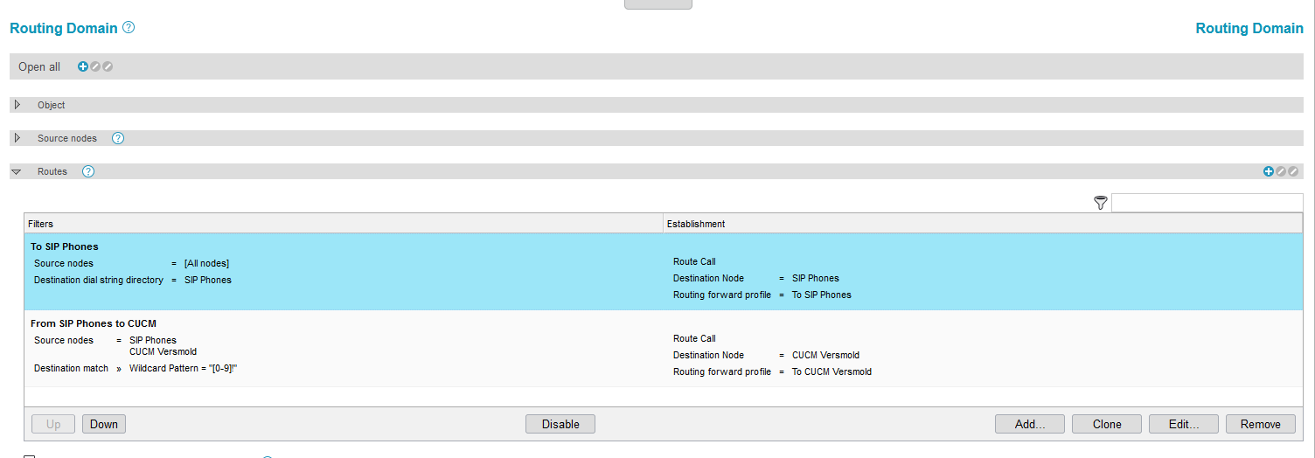
In the routing forward profile the „Telephony forwarding“ has to be configured as in the following example:
In „SIP phones“ routing forward profile select „To SIP Trunk“ in the telephony forwarding field:
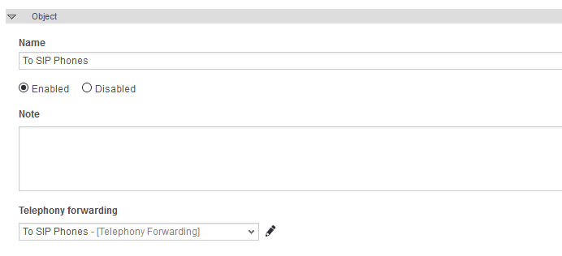

In the CUCM routing forward profile set the „telephony forwarding“ to „To CUCM“:
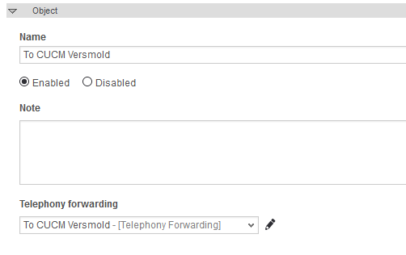

  - Number manipulation
If you use E164 you can add some rewriting rules in the CUCM node:
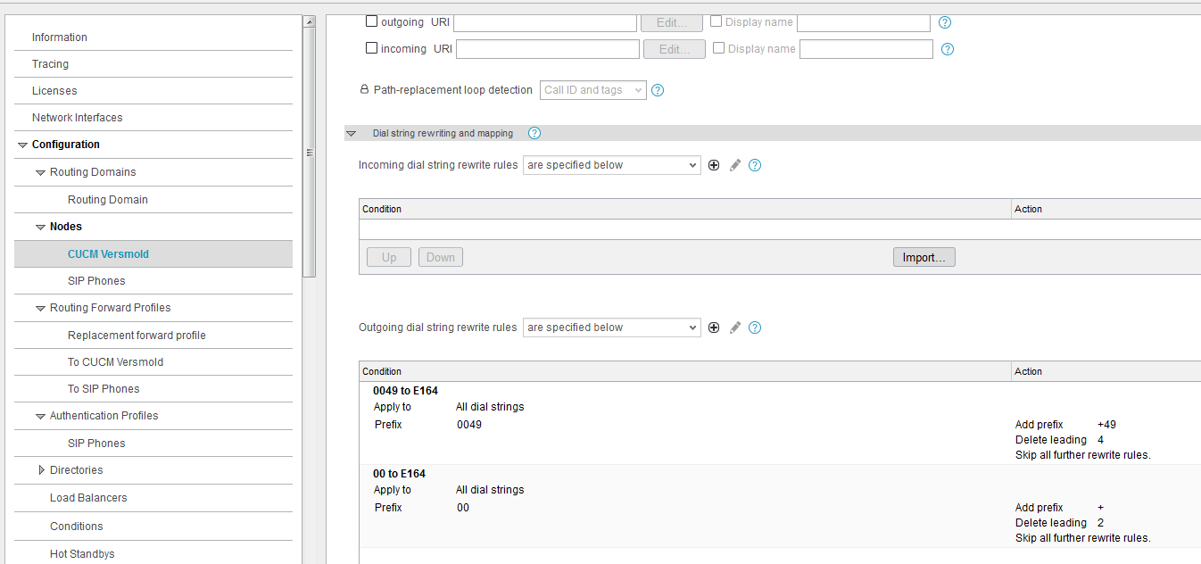
  - Special parameters
Some special parameters have to be set that call transfers are working correctly:
The the SIP phones node, click on “open all” and switch to the highest detail level “+++”:
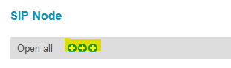
in the “call transfer” tab click on the little lock on the left and in “Blind transfer mode” select “pass the REFER along”:
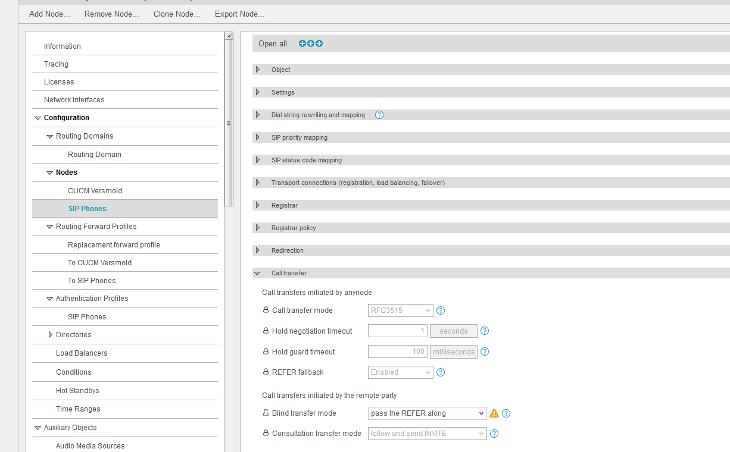
Go to the “To CUCM” routing forward profile, expand the detail level to (+) and select “telephony forwarding”:
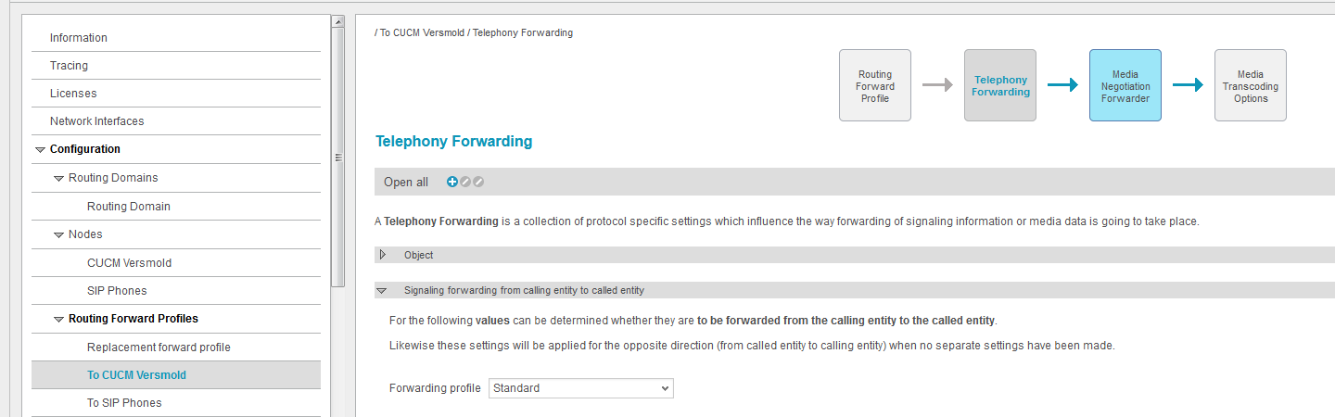
In the “signaling forwarding from calling entity to called entity” tab under “SIP refer forwarding” click on the little lock on the left and select “Enabled” on “Forward SIP REFER requests”:’
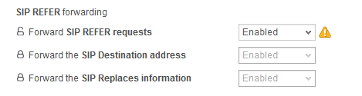
The same configuration has also to be done on the “SIP phones” routing forward profile.

- Gigaset
On the Gigaset device the provisioning server has to be set as in the following example:
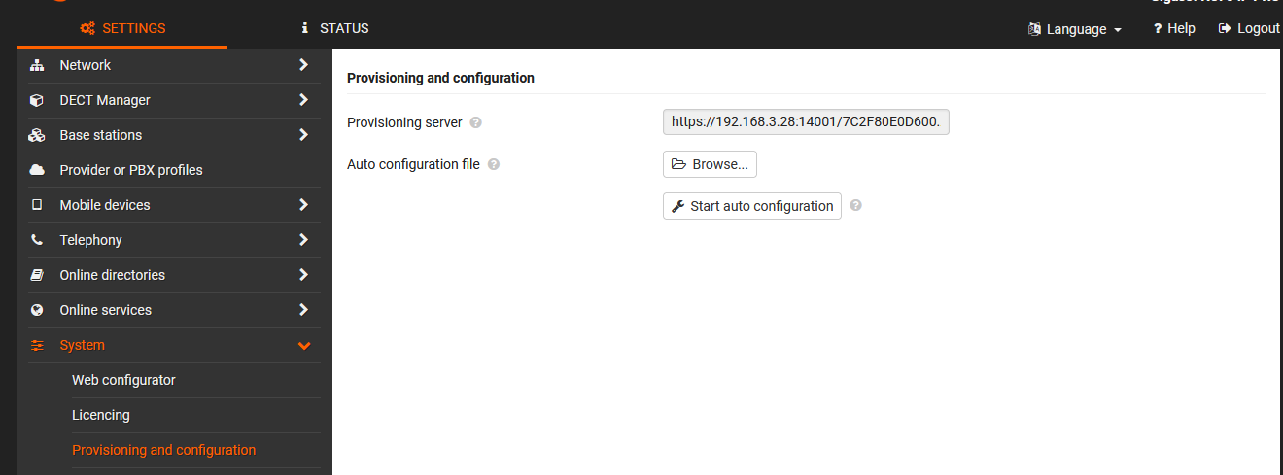
The URL contains the MAC address of the device:
In our example: https://[IP-Address of Anynode]:[Port configured in Anynode]/[MAC-Address N870].xml
e.g. https://192.168.3.28:14001/7C2F80E0D600.xml
Click on “Set” and on “Start auto configuration” to download the configuration from the provisioning server.

The registration of the handsets are standard. Please refer to the user manual.

- Appendix:
  - Test environment description:
    - IP Addresses:
In our test environment the Anynode SBC had two IP addresses:
192.168.3.28 was the interface for the CUCM SIP trunk
192.168.3.29 was the interface for the SIP client registration
192.168.3.30 was the IP address of the CUCM
    - Versions:
      - CUCM version: 11.5.1.18900-97
      - Gigaset N870 IP Pro: V2.47.0
      - Anynode SBC: 4.6.15 on Debian Linux
it is recommended to use the 4.6.15 version or newer. In older versions the “REFER” parameters can not be changed.

